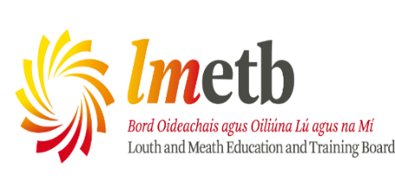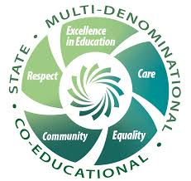

Board of Management Agreed Report

A Meeting of the Board of Management of Ard Rí CNS took place in the school on 11/12/2025 from 7- 8pm

Agreed Report
- The Board of Management approved the minutes of the previous meeting on 11/09/2025
- The Child Protection Oversight Report was presented, read, discussed and noted
- Bullying Behaviour Updates as per Bí Cineálta were presented, read, discussed and noted
- The Board of Management was presented with the most recent Finance Report from Finance Section LMETB. The report was read, discussed and noted.
- The Board of Management was presented with a report on Green Schools/Sustainability initiatives in the school. The report was read, discussed and noted
- The Principal provided a report to the Board of Management including updates on Teaching, Learning and Assessment and Department of Education and Youth Inspections since the last meeting of the Board of Management
- The Board of Management ratified the following Policies:
Statement of Strategy for School Attendance December 2025
Relationships and Sexuality Education (RSE) Policy December 2025
- The Board of Management was provided with an update of Student Voice Activities and Initiatives. The report was read, discussed and noted.
- The Board of Management was provided with a report from the Parents Association. The report was read, discussed and noted. The Board of Management also considered any proposed fundraising initiatives.
- The Board of Management expressed their congratulations to Niamh Hogan, Karen Dunne, Lauren O’Brien, Aoife Mc Cluskey. The Board of Management expressed their sympathies to Aoife McCluskey, Linda Smith and the Dunne family.
- The next meeting of the Board of Management is scheduled for 03/02/2026 at 7pm

