November/December Newsletter
I would like to thank everybody for their support since September. The boys and girls are being kept busy with trips to the library, Irish Dancing lessons, football, our first day out in INTO Cumann na mBunscoil mini-7s, cross-country and rugby training, mini-athletics, Kickhams, Roald Dahl Day, Maths Week, the Pumpkin Carving Competition, Bedtime Stories, Skip n’ Rope lessons, nature walks as well as all the hands on, high quality curriculum learning each day. We hope that immersing your children in this positive environment where they receive exposure to as many high quality learning experiences as possible they will thrive, be positive about learning and develop good mental strength.
We are developing an Attendance Policy for the school at present. We hope to promote a culture of good school attendance in our community. Congratulations to Rang Maria who had an attendance rate of 98.6% in October. In order to help in the fight against germs and absences due to illness, it can be a good idea to pop a small hand sanitiser into your child’s lunchbox and train them to sanitise their hands before they eat.
We continue to promote good health for our pupils. There are lots of opportunities for our children to get up and get active during the school day. Continue to send lots of yummy fruit and veg in your child’s lunch-box each day.
A huge thank you to the Parent Association who raised €511 for the 5th and 6th Class library through last month’s clothing collection. They also held a very successful Cyber-Safety Workshop last week. Please find the Parent Association newsletter attached.
In October Ard Rí Community National School had our first ever Board of Management meeting. Members of the Board of Management are as follows: David Cullivan (Chair), Linda Duffy, Catherine Dooley, Darragh Roe (Secretary), Paul O’Toole, Lynsey Ginnity, Rebecca Meade and Séamus Kenny. During the meeting the board formally adopted reviewed Child Protection and Enrolment Policies.
Due to objections to our planning permission there will be a delay in the installation of new classrooms at Balreask Old. I will keep you posted on any progress which is made here. We are having to do the best we can with the resources we have.
As the weather gets colder and our coaches are preparing children for inter-school competitions there will be no more Kickhams until February.
Cool beans,
Darragh

Here is an outline of upcoming events;
Irish Dancing: Mark Hennessey has been teaching Irish Dancing to the children. Mark will continue to teach dancing to all children on Tuesdays. The children will perform the dances and songs they are learning in The Ardboyne Hotel for the 2016 Winter Show. The cost of these lessons is €10 per child. If you haven’t yet made payment please submit payment to your child’s class teacher as soon as possible.
Monday 13.11.2017: Meath Enterprise Board will hold an enterprise workshop for the boys and girls in 5th and 6th Classes.
Wednesday 15.11.2017: Our u-11 and u-13 boys and girls will compete in an inter-school cross-country competition in Bellewstown.
Monday 27.11.2017: Boyne Dental will visit classes Junior Infants to Second to teach them about oral hygiene and health. They will visit all other classes at a later date.
Wednesday 06.12.2017: Junior and Senior Infants will travel by bus to visit The Solstice Theatre to see Hansel and Gretel. There will be further information about this trip closer to the time.
Wednesday 20.12.2016; We will hold our Winter Show in the Ardboyne Hotel from 10am. There will be a cake sale in the school hall after. All welcome. As children have paid for dance lessons there will be no charge for admission to The Winter Show.

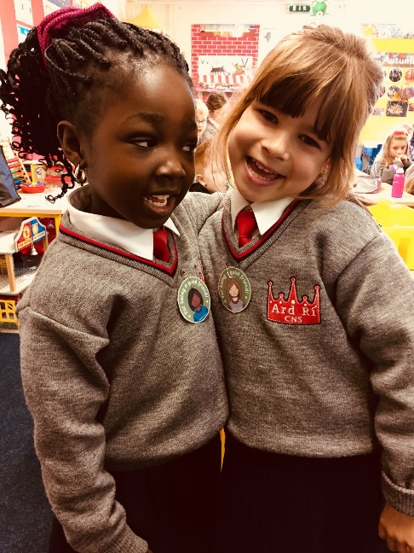
(Left) Junior Infants receive Good Friend badge for kind words (Below) Ard Rí Kickhams at our first mini-7s Gaelic football match

Ard Rí Winter Food Drive
Navan Meals on Wheels is looking for help this year. While we would like to help people who are experiencing difficulties we don’t want to put pressure on any of our parents who may be facing financial difficulties of their own.
We are hoping to make up a hamper from each class. I have listed the required items below. With your child choose an item from the basic list, and if you would like you can also choose an item from the additional treat item list. PLEASE don’t put yourself under any pressure. We have asked the Parent Association to provide a small voucher from the local butcher for each hamper so we are asking you not to send in any perishable items. It might be a nice idea to suggest the children buy their item themselves, if they get pocket money, to make it more meaningful for them. Please have your items in by Friday 24.11.2017.

Basic Items: Send in the highlighted item please (check all use by dates are well into next year)
Breakfast cereal Packet/tinned soup
Pasta Tinned vegetables – peas/beans/corn
Rice Tinned fruit
Noodles Tinned fish
Tea Jar of pasta sauce
Coffee Jar of ‘Uncle Ben’ type sauce
Salt Custard
Stock cubes Biscuits
Sugar Hot chocolate
Jam Mayonnaise
Ketchup

Additional treat items – if you are interested in adding these:
Christmas cake Christmas pudding
Christmas selection box Chocolate
Mince pies Crisps
Popcorn Sweets
Turkey voucher Ham voucher
Christmas crackers Festive napkins

Thank you very much for your support.

