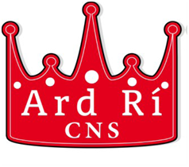

APPLICATION FOR ADMISSION

This is an application form for admission and does not constitute an offer of a place, implied or otherwise.
 |  | YEAR FOR ADMISSION | CLASS
PUPIL’S SURNAME
PUPIL’S FIRST NAME |  |  |  |  | Male | Female
DATE OF BIRTH

ADDRESS
(Primary Residence)

MOTHER’S NAME, | Name
FATHER’S NAME, | Name
TELEPHONE NUMBERS: | HOME |  |  | MOBILE
NAME AND ADDRESS OF PREVIOUS SCHOOL/ PRE-SCHOOL

Signature: __________________________________ Date:_____________
(Parent/Guardian 1)

Signature: __________________________________ Date:_____________
(Parent/Guardian 2)
All applications should be returned to:
ADMISSIONS,
Ard Rí Community National School,
Balreask Old,
Navan.
Email: DRoe@lmetb.ie
The following items must accompany your application:
- An Original Long Form Birth Certificate (together with a photocopy)see note 1
and
- Two of the following (dated within 2 months of date of application) see note 2
a) ESB Bill
b) Gas Bill
c) Landline Telephone Bill
d) NTL/ TV Bill
Note 1:The birth certificate is required to prove your child’s date of birth
Note 2:The utility bills are required to prove you are living within the catchment area of the school.
When photocopying the utility bills you may delete the financial information as we only require the name and address.
All of the information you provide in this Application Form is taken in good faith. If it is found that any of the information is incorrect, misleading or incomplete, the application will be rendered invalid.
We reserve the right to use any necessary means to verify proof of primary residence.

